**Study Guide Exam 2 Neuroanatomy**

40 MC Questions

Diagram labeling:

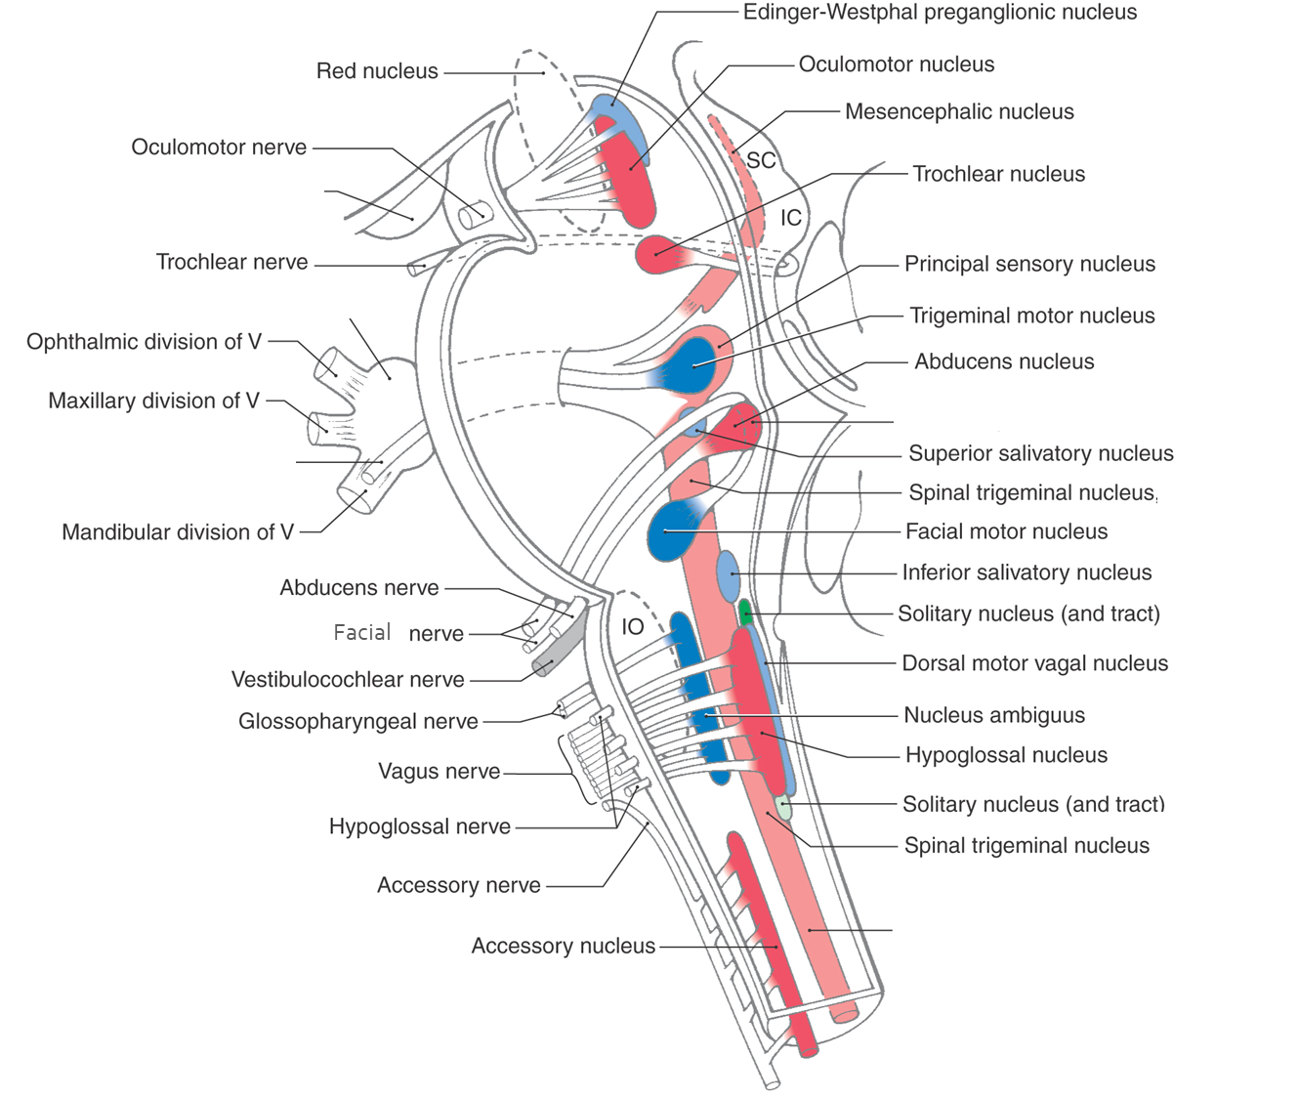

Identify (MC questions) areas of midbrain cross-sections

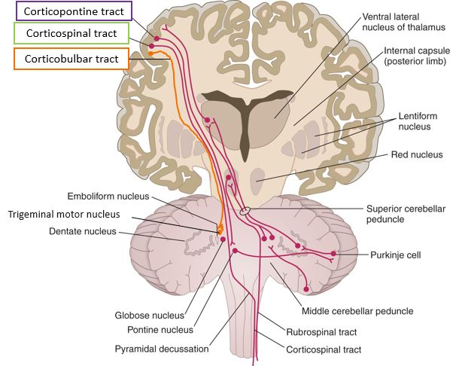

Hypothalamic nuclei & their functions

Specific Brodmann’s areas (went over them in class) & their functions

Ventral visual stream processing areas (label & function)

Pathways to describe:

Light reflexes

Cerebellar input pathways

Receiving sensation from an extremity

Other areas of focus:

Visual & eye muscle conditions

Clinical applications from lecture (all chapters)

Functions & pathways of cranial nerves & nuclei

Functions & projections of non-corticobulbar nuclei (i.e., nucleus ambiguous, etc)

Lobes, functions, and input/output pathways of cerebellum

Spinal tract pathways into the brain stem/cortex (only a couple of basic questions regarding vestibular nuclei- we come back to this in a later chapter)

Identifying clinical conditions via neuroimaging

Diencephalic nuclei, stria, & pathways (behavioral effects of lesioning or stimulating also)

Structure & function of limbic and basal ganglia components (very simple)

Layers of the eye, functions & sub-layers/structures/cells/muscles

Parasympathetic visual pathways

Dorsal and ventral visual streams, areas on each

*This list is not all-inclusive and some areas are subject to change as I continue to refine the exam.*